Graduate Students: How to Tag your Paper as a Grad Student Submission on eTutoring.org

From your eTutoring homepage, click on the eWriting Lab:
As soon as you enter the eWriting Lab, you’ll see a policy pop-up written specifically for the eWriting Lab. Please read the pop-up carefully.

When you have closed the pop-up, your eWriting Lab submission options will appear (see below).
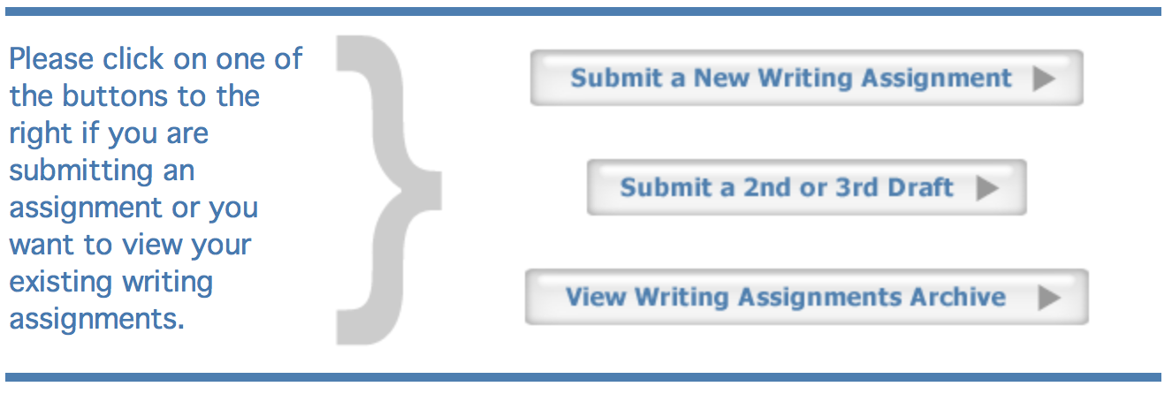
Select “Submit a New Writing Assignment.” When you have opted to submit a new writing assignment, the submission form will appear on your screen. The submission form is quite extensive, but please fill it out as much as possible. The more information you provide, the more we’ll be able to help you with your work.

For example, if you have a digital copy of your assignment from your professor, you may upload it so our tutors can take a look.

Pay particular attention to the bottom of the form; click on “Graduate Student Submission” in order to flag your paper as a graduate-level submission.

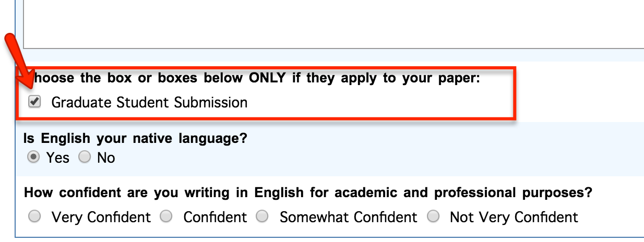

Note: If you do not select “Graduate Student Submission” your paper will not be readily identified by our grad tutors when they look through the eWriting Lab queue for tagged graduate student submissions. This may mean a delayed response from the tutors and a longer wait time for you.

Then upload your file and push the button that says, “Submit Your Writing Assignment.”

Thanks for posting your work!

